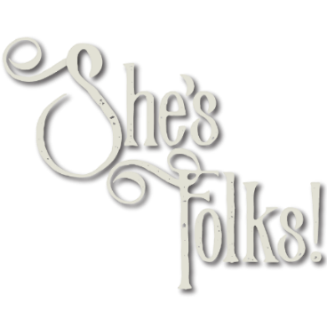
FOR IMMEDIATE RELEASE

Contact:
Elizabeth Morgan at: shesfolks@shesfolks.com for guest list, interviews or promo
copies of Elizabeth Morgan: She’s Folks
Visit online: http://shesfolks.com/

Elizabeth Morgan of She’s Folks Has Big News
for the 2017 Holiday Entertainment Season

Elizabeth Morgan to bring the She’s Folks Holiday Hootenanny to Steppenwolf’s LookOut Series and Metropolis Performing Arts Center

Elizabeth Morgan announces November Album Release of Elizabeth Morgan: She’s Folks

CHICAGO (November 2017) “Betsy” and the “Boys” are starting off the 2017 holiday season with a She’s Folks album release, Elizabeth Morgan: She’s Folks on November 14. Then they’re putting on the snow tires and loading up for the She’s Folks Holiday Hootenanny, with the first stop at Steppenwolf’s 1700 Theatre for performances on Thursday and Friday, December 7 and 8. She’s Folks will appear the following week at Metropolis Performing Arts Center, Tuesday, December 12.

Just in time for the holidays, Morgan is adorning her concert-style onstage memoir with a Yuletide garland for a She’s Folks Holiday Hootenanny, a Christmas card to the country from a kid who couldn’t wait to leave. Journey from the city to the farm through hilarious stories, soaring harmonies, and a wry but affectionate view of the folks back home. Integrating acoustic folk and country music, comedy, theatre, and storytelling, Morgan invites the audience to climb aboard and travel by truck, train, and tractor on a trip back to her native Midwestern byways, railroads, and fields. Old time string music meets the rust belt as the audience is treated to original tunes such as I-90 Take Me Home, The Threshold, and Little Town Girl as well as a medley of holiday hymns, seasonal classics such as Silent Night, and country gems like, Christmas Time Is A Comin’, all tied up with one heck of a story about a goat.

Originally from rural Ohio, Chicago-based entertainer Elizabeth “Betsy” Morgan is an actor, singer, writer, musician, and storyteller. She's Folks was created by Morgan in 2015 for a one-night-only cabaret event at Davenport’s Piano Bar and featured covers of country and folk rock music. Well received, She’s Folks began performing the show at small venues throughout Chicago. Morgan’s unique compilation is a hilarious, heartwarming, slightly acerbic homage to her rustic upbringing entwined with her love of traditional, gospel, and folk music.

It wasn’t long before Betsy infused the She’s Folks experience with her original songs, as well as new arrangements of traditional folk pieces, transitioning She's Folks from cabaret to an original concert-style piece showcasing her signature "Story, Song and Sass." In August of 2016, Betsy and the Boys debuted with two sold-out nights at Steppenwolf's newly minted LookOut theatre. In December of 2016, they premiered the She's Folks' Holiday Hootenanny at Chicago’s Athenaeum Theatre.

For a refreshing holiday treat, dust the snow off the pickup and join She’s Folks for a heapin’ helpin’ of Story, Song and Sass!

SHOW DETAILS

The Band:
Elizabeth Morgan - Lead Vocals, Piano, Guitar
Tyler Thompson - Vocals, Banjo
Alex Newkirk - Vocals, Piano
Ted Kitterman - Vocals, Strings
Tyler Core - Percussion

2017 PERFORMANCE DATES

December 7 & 8, 8 pm
Steppenwolf’s 1700 Theatre, 1700 N Halsted, Chicago, IL 60614
https://www.steppenwolf.org/

December 12, 7:30 pm
Metropolis Performing Arts Center, 111 W Campbell St., Arlington Heights, IL 60005
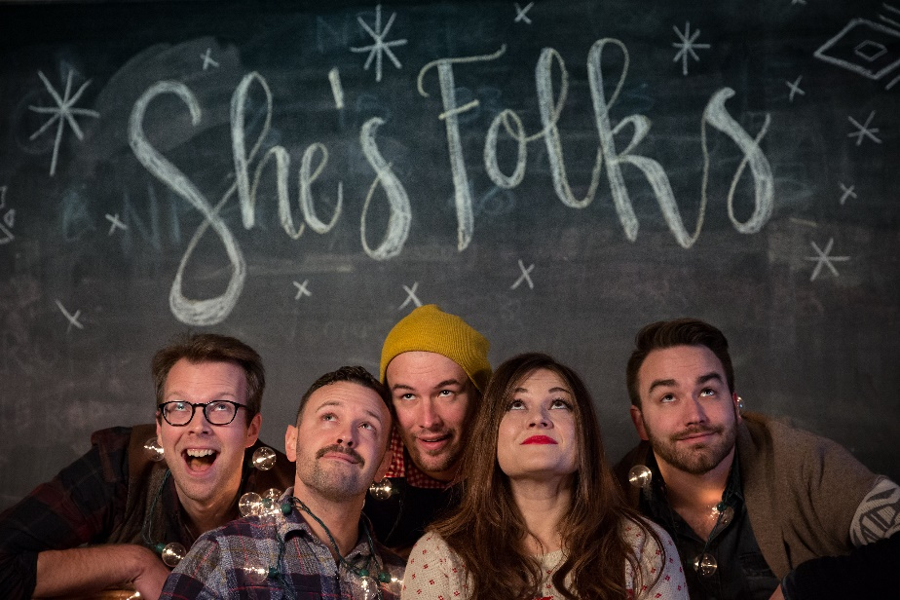
http://metropolisarts.com/

# # #

